4C Organic chemistry review
1. Define organic chemistry. What are the properties of organic chemicals?
2. What are the unique properties of carbon?
3. What is the name of a 3 carbon side chain? A 4 carbon side chain?
4. Name the following
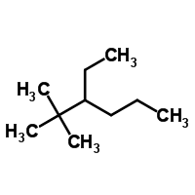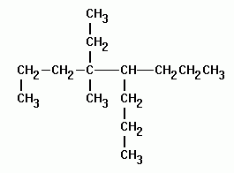
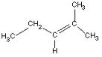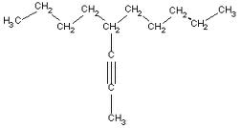

5. Draw 7-methyl-4-propyl-3-octene, 4-butyl-5-ethyl-7-methyl-2-nonyne.
6. What is the atomic mass of octane?
7. What is benzene?
8. What is a non-polar covalent bond? Example?
9. What is a polar covalent bond? Example?
10. Draw H₂S showing electronegativities. (δ) What are the pauling’s numbers for this compound?
11. Why do non-polar compounds not dissolve in polar compounds?
12. Why do polar compounds dissolve in polar compounds?
14. What is a functional group?
15. Circle and name the functional group. Name the family as well.

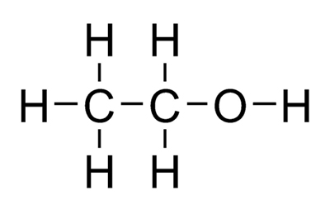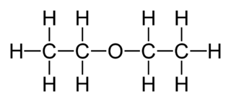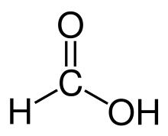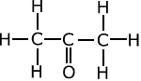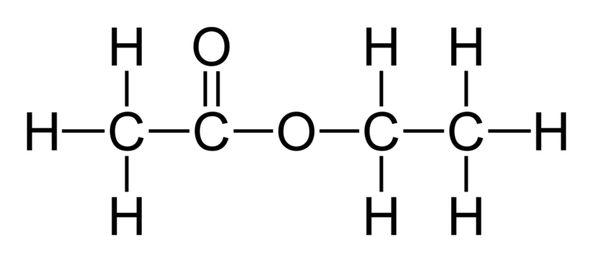

16. Which functional groups are soluble in water? Why:
17. How does soap work?
19. What is saponification?

20. What is esterification? Write the chemical reaction for the esterification of :
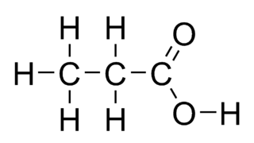+ 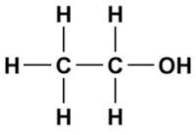 ->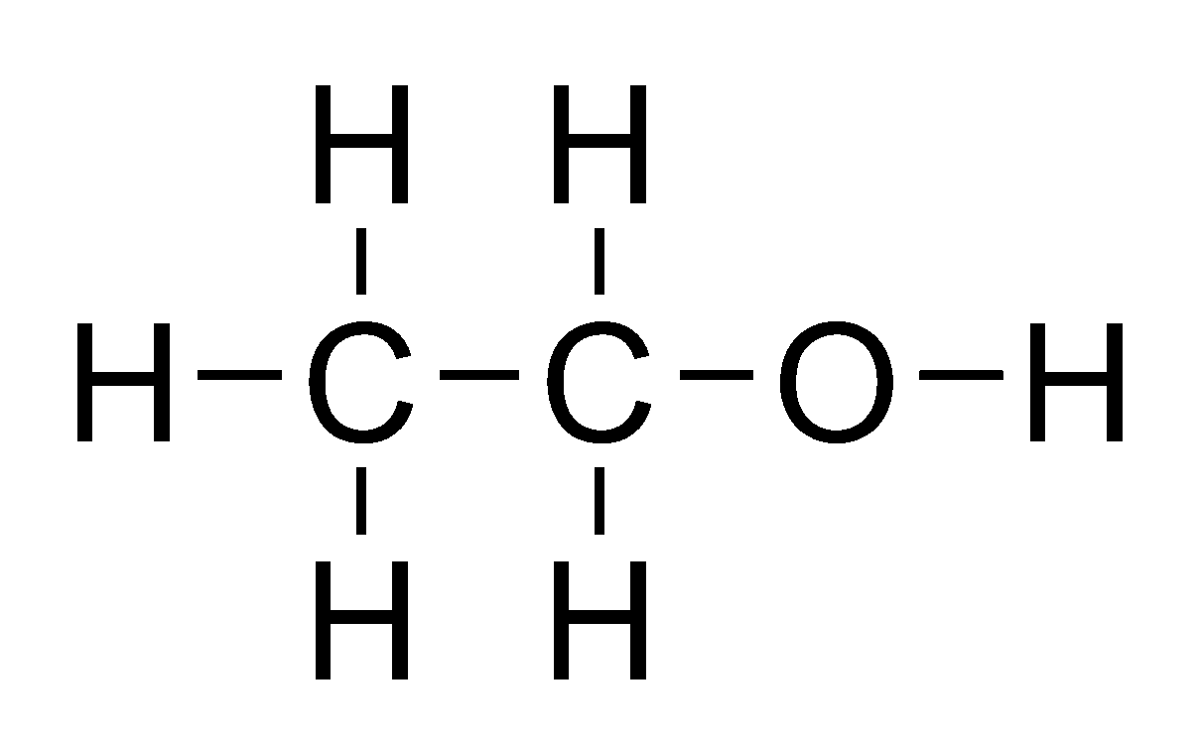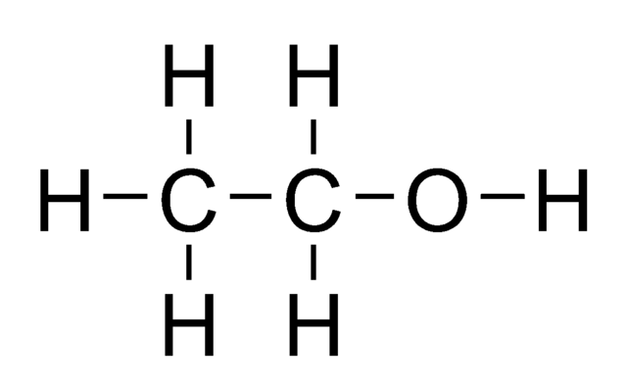

21. What is a polymer? Show the chemical reaction to make a polymer using :
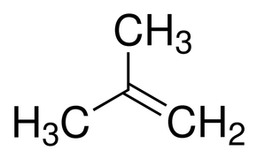 + ->

22. What is a cross-linker?
23. What is complete, incomplete and very incomplete combustion? What conditions are required for each?
24. Complete the following and balance: Complete combustion of C₆H₁₂
Incomplete combustion of C₆H₁₂
Very incomplete combustion of C₆H₁₂
25. What is a structural isomer. Draw 2 structural isomers of a 5 carbon compound.

Lab Book

*Fractional Distillation and Cracking
*Functional Groups
*Refining and Using Hydrocarbons
*Safe Use of Organic Solvents
*Vulcanized Rubber
*Water Bottles BPA
*Saponification (Soap Making)
*Bath Bomb
*Synthesis of Esters
*Slime (Cross-linking Polymers)
*Let Me Count the Ways (Isomers)

