Electronegativity and Polarity

When covalent bonding occurs, the sharing of the electrons between the atoms is not always equal. **Electronegativity** is a measure of an atom’s ability to attract the pair of electrons it shares with another atom within a covalent bond. Table 1 on page 40 lists the electronegativity of some elements. Electronegativity occurs because of the radius for some atoms is larger or smaller than other atoms. If there is a large radius, the electrons are farther from the positive nucleus and therefore the attraction is weaker which results in a low electronegativity. The opposite is true that atoms with a smaller atomic radius have a higher electronegativity. A **non-polar bond** is a bond where the sharing is equal between the two atoms. A **polar bond** is a bond where the sharing is un-equal between the two bonds (the electronegative difference is more than 0.5).

Example 1: Write polar or non-polar beside the following bonds. NOTE: If the difference in electronegativity is exactly 0.4 or less, the bond is non-polar. For polar bonds indicate which atom is slightly positive and which is slightly negative.

1. C & O
2. F & F
3. C & H
4. C & N
5. O & O

Organic Compounds:

* Organic compounds containing **nitrogen** and **oxygen** bound to a hydrogen are usually polar molecules
* Molecules which contain non-polar bonds are called **non-polar molecules**
* Hydrocarbons are non-polar molecules because carbon and hydrogen share the electron in their covalent bond fairly **equally**, forming non-polar bonds

Polar Organic Compounds

* Some organic compounds contain **nitrogen** and/or **oxygen** in addition to carbon a hydrogen
* These types of organic compounds are important because they have **physical properties** that are very different from hydrocarbons

### Physical Properties of Polar and Non-Polar Molecules

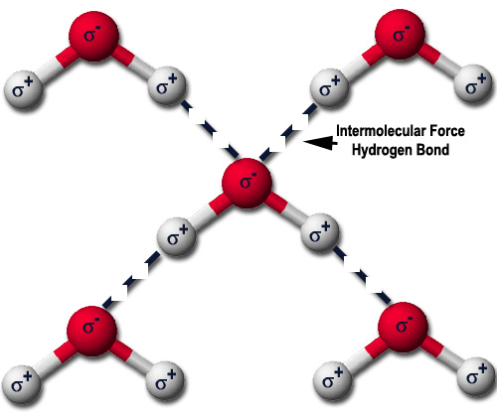**Intermolecular forces:**

* The **partial charge** of a polar molecule leads to **intermolecular** forces
* *Intermolecular* means **between** molecules
* Oppositely charged parts of the molecules are **attracted** to each other
* This attraction effects two important **physical properties** of the molecules: solubility and boiling point

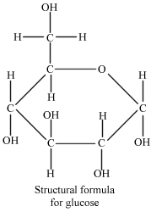**Solubility:**

* Polar solutes are able to **dissolve** in polar solvents
* For example, glucose is a polar organic compound which can dissolve in **water**, which is a polar solvent
* **Non-polar** solutes can dissolve in non-polar solvents
* For example, non-polar hydrocarbons can dissolve in other non-polar hydrocarbons (hexane will dissolve in octane)
* However, hexane will **not** dissolve in water
* **Like dissolves like**

**Boiling Point:**

* A substance will **boil** (turn from a liquid to a gas) when the molecules it is composed of have enough energy to overcome the **intermolecular forces** that hold it together as a liquid
* Once this energy is obtained, the molecules can move **faster**, and **spread further apart**, making them gases
* Polar molecules have a **higher** boiling point compared to non-polar molecules of the **same size**
* This is because the polar molecules have **stronger intermolecular** forces to overcome